
Chesham & Amersham Conservative Association

Welcome Drinks for New Members
- with -
The Rt Hon Dame Cheryl Gillan DBE MP

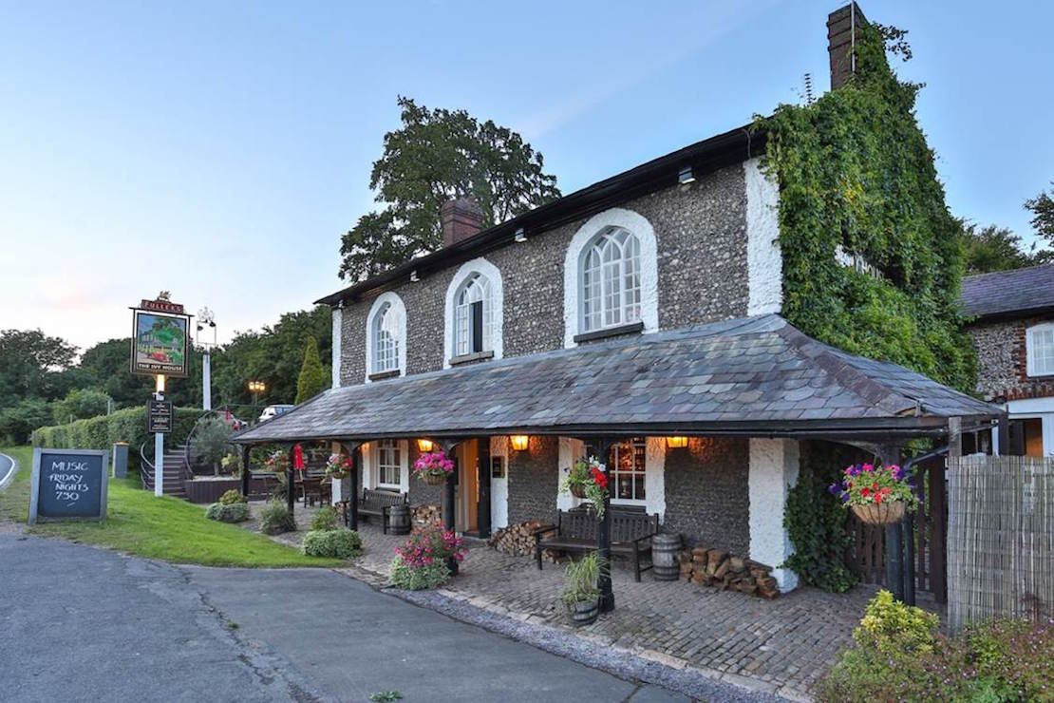

The Ivy House, Chalfont St. Giles, HP8 4RS

Thursday 5th September @ 7pm – 8.30pm
Free Entry
Pay bar and complimentary nibbles

RSVP to Philip Dumville
Tel: 01494 673745 Email: office@cheshamandamershamconservatives.co.uk

